Name: ____________________ Period: ____ Date: ________

Worksheet: Pools and Fluxes

Part I.
Carbon is the most important element for living things. Every single living cell on Earth–plants, animals and humans—is made with carbon atoms. Humans are about 18 % carbon atoms by weight, and a human being who weighs 150 pounds contains about 7 hundred trillion carbon atoms (that’s 7 followed by 26 zeros!). That’s a lot of atoms. Carbon is such an important element that when scientists want to study large populations of living things (for example when they’re thinking about grasses in a meadow, or trees in a forest), scientists can study these living things just by counting carbon atoms. Looking at the world by counting carbon atoms allows scientists to think on a ecosystem-sized scale or even Earth-sized scale about where living things are located and how they change. Global climate change, for example, is causing lots of living things to change, and counting carbon on the landscape gives us important information about those changes.

In many ecosystems, one important place where lots of carbon atoms are located is in trees. Dr. Andres Schmidt at Oregon State University is an atom counter. He uses high-tech tools to measure carbon atoms, like 150 feet high towers that let him look out over the forest canopy. These towers count carbon atoms in the form of carbon dioxide (CO₂) molecules in the air, as well as keep track of meteorological conditions like moisture and temperature. There are more than fifty of these towers all across the United States in a network called AmeriFlux. These scientists want to know if forests can absorb extra carbon in the air due to fossil fuel combustion.

Scientists use special words, “pools” and “fluxes” when counting atoms. Carbon pools are reservoirs of carbon atoms in a particular part of the ecosystem, like plants, soils, animals or air. Pools are thought of as bigger than one individual animal or tree; for example, a pool could be all the grasses growing in a meadow ecosystem or all the rabbits living in a meadow ecosystem. In ecosystems we think of major pools of carbon as soil, plants, animals and air. Pools can be lots of different sizes, and scientists even talk about the “all the vegetation in the world” as one pool of carbon. Pools are usually measured by the mass of carbon in an area (for example, pounds of carbon per acre). Scientists like Dr. Schmidt also measure pools in lots of “low-tech” ways—they may actually walk through the forest measuring trees and fallen logs and collecting leaf litter! Since plants are about 50% carbon, the scientists like Dr. Schmidt are able to estimate how many carbon atoms are in a pool just by measuring trees and collecting leaves!

Fluxes are movements of carbon from one pool to another. Carbon moves through ecosystems by the carbon-transforming processes that we have studied: photosynthesis, respiration, biosynthesis, digestion (and combustion! We will talk about this soon). Fluxes are “rates” because they are measured as the amount of carbon that moves from one pool to another in a particular unit of time (for example, pound of carbon per acre per year). A flux is usually measured on a big scale, just like pools. For example, when the sun is shining on a forest, scientists like Dr. Schmidt can actually detect photosynthesis as a movement of carbon from the air pool to plant pools. When trees take in carbon during photosynthesis, the CO₂ in the air decreases above the forest. This movement of carbon from one pool to another is a flux!

Dr. Schmidt has a useful analogy for thinking about pools and fluxes. You can imagine a pool of carbon atoms like water in a swimming pool. Fluxes could include water that comes into the pool (like water from a hose), or water that leaves the pool (like a drain at the bottom). The water in the swimming pool might increase for two reasons: because water floods from the hose at a greater rate, or because the drain closes to a drip. In forests, water coming from the hose is like carbon entering the forest pool during flux from photosynthesis, and water leaving through the drain is like carbon leaving the forest pool during flux from respiration. Forest pools increase or decrease depending on photosynthesis and respiration rates. Forests may absorb 2000 pounds of carbon per acre (in a certain amount of time) in photosynthesis, but then respire 1,500 pounds of carbon per acre (in the same amount of time). That would leave 500 pounds of C in the forest pool. An “increase in the carbon pool” of a forest simply means that the trees are growing!

Part II
In the carbon game, where were all the pools of carbon? In the picture below, the pools are represented by boxes.
  - Draw a heart on the boxes that represent organic pools of carbon.
  - Draw a diamond on the boxes that represent inorganic pools of carbon.
In the carbon game, what were all the fluxes? In the picture below, find the arrows that represent fluxes.
  - Draw a triangle on a flux arrow that increases levels of CO₂ in the air.
  - Draw a star on a flux arrow that decreases levels of CO₂ in the air.
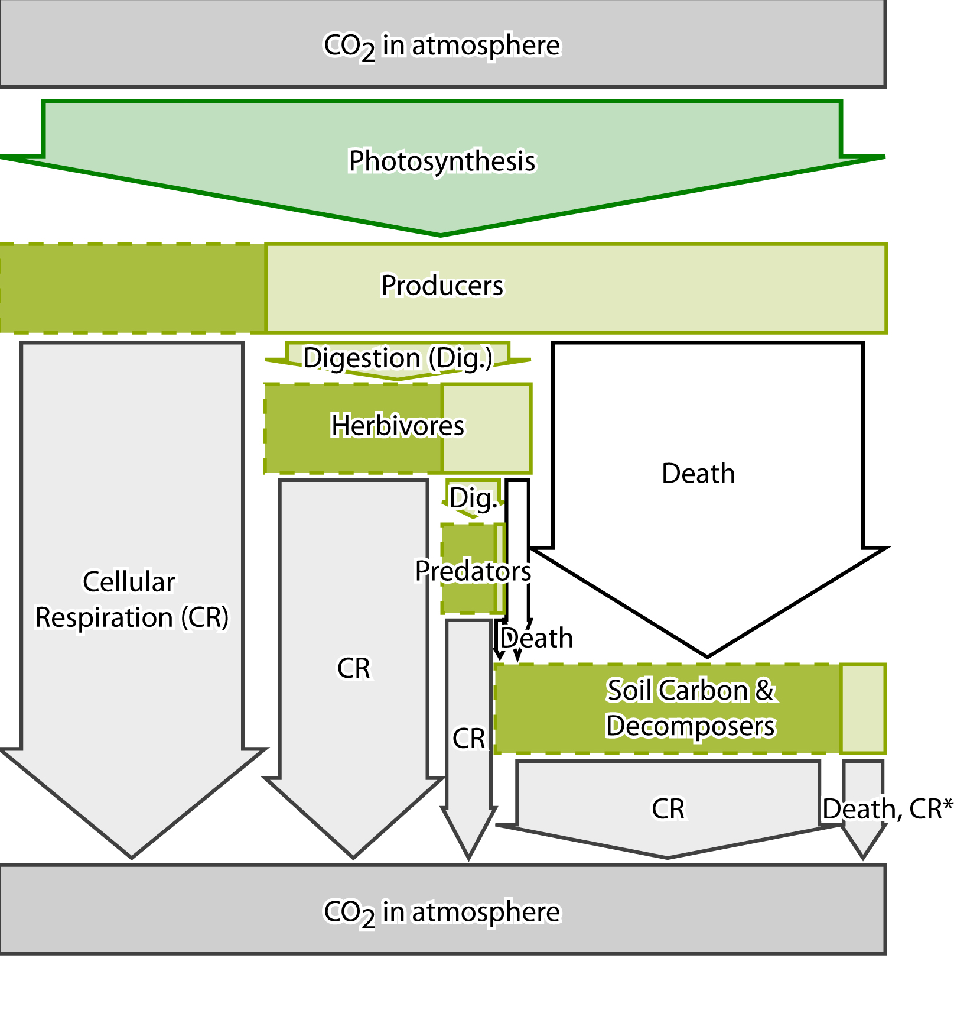

Part III
Read each scenario. Put a check next to the best choice. Explain your choice underneath each example.

In South America 2 million acres of cattle farm is planted with trees and turned into a forest.
☐ Increase carbon in the atmosphere.
☐ Decrease carbon in the atmosphere.
Explain:

The prairie surrounding the Gobi Desert disappears due to over-grazing by cattle. The desert spreads into the area where prairie used to be, covering the area with sand.
☐ Increase carbon in the atmosphere.
☐ Decrease carbon in the atmosphere.
Explain:

A prairie is plowed to make a cornfield. The plowing of the field breaks up plant roots and stems, so that they are digested more rapidly by decomposers.
☐ Increase carbon in the atmosphere.
☐ Decrease carbon in the atmosphere.
Explain:

Wind turbines are used to generate electricity at a power plant instead of burning coal.
☐ Increase carbon in the atmosphere.
☐ Decrease carbon in the atmosphere.
Explain:

In the Amazon Rain Forest, 2 million acres of trees are harvested to make room for a cattle farm.
☐ Increase carbon in producers.
☐ Decrease carbon in producers.
Explain:

Cattle are removed from the prairie surrounding the Gobi Desert. The prairie regrows and stops the spreading of the Gobi desert.
☐ Increase carbon in producers.
☐ Decrease carbon in producers.
Explain:

In Yellowstone National Park, wolf populations are increasing and they are eating more elk calves.
☐ Increase carbon in consumers.
☐ Decrease carbon in consumers.
Explain:

